PLDT TRIDENT

Software Release 20.03

PLDT – 3c - Kenan Bill Discounts - IDD

Interface Design Document

Version 0.1

Document Information

| Software Release: | 20.03 |
| --- | --- |
| Catalog Number: | **document_center\4337583 Version 0.1** |
| Information Security: | **Level 1 - Confidential** |
| Account/FOP: | **PLDT - Project 3c AIA - IDDs** |
| Author: | **Eyal Bekerman** |
| Editor: | **Eyal Bekerman** |
| Last Edited: | **Oct-11-2022 12:09:46 PM** |
| File Name: | **PLDT - 3c - Kenan Bill Discounts - IDD.docx** |
| Template: | **New Development.dotm** |

Document Release Information

| Editor/Author | Edit Date | Section | Changes | DC Ver. |
| --- | --- | --- | --- | --- |
|  |  |  | |  |
|  |  |  | |  |
|  |  |  | |  |
|  |  |  | |  |
|  |  |  | |  |
|  |  |  | |  |
|  |  |  | |  |
|  |  |  | |  |
|  |  |  | |  |
| Eyal Bekerman | Sep-21-2022 | Document created | | 0.1 |

Table of Contents

Table of Contents ii

1 Introduction 1

1.1 Purpose and Scope 1

1.2 Related Documentation 1

1.3 Terms and Definitions 1

2 General Information 2

2.1 Technical Information 2

2.2 General Assumptions 2

2.3 Interface Master List Traceability Matrix 2

3 Bill Discounts File Extracts 3

3.1 Bill Discounts 3

3.1.1 Description 3

3.1.2 Assumptions 3

3.1.3 Flow Diagram 3

3.1.4 Flow Description 3

3.1.5 Bill Discount Request 4

3.1.6 Bill Discount Response 5

4 Open Issues 7

# Introduction

## Purpose and Scope

This document describes the design of interfaces between two systems:

* Amdocs Engage
* Home Kenan

The document describes the data requirements and interface detailed specifications of data extracted by Amdocs Engage.

It is used as input for the Detailed Design and Testing stages of the Development process.

## Related Documentation

The following documents will assist the reader in obtaining a broader understanding of the subject-matter of this document:

| DC# | Document Name |
| --- | --- |
|  | HLD - DMND0008859 Bill Discount Capability V2.4.docx |
|  |  |

## Terms and Definitions

Following is a list of terms used in this document with which the reader should be familiar:

| Term/Acronym | Definition |
| --- | --- |
|  |  |
|  |  |

# General Information

## Technical Information

This document provides the reader with detailed interface agreement specifications for sending bill discount requests from Amdocs AIA to Home Kenan. The document provides all the information required to estimate the work and the tasks to realize this interface.

## General Assumptions

| Unique ID | Assumption |
| --- | --- |
|  |  |
|  |  |

## Interface Master List Traceability Matrix

| S.No | IML ID | IML Description | IDD Section |
| --- | --- | --- | --- |
| 1 | AIA224 | Home Bill Discounts | 3.1.5 |
| 2 | AIA225 | Home Bill Discounts Responses | 3.1.6 |

# Bill Discounts File Extracts

## Bill Discounts

### Description

Kenan will provide a file-based interface via SFTP which will be used by Amdocs Engage to send the bill discounts requests.

Amdocs Engage will provide a file-based interface via SFTP which will be used by Kenan to provide feedback information.

### Assumptions

1. All monetary amounts are in pesos.

### Flow Diagram

Figure ‎3‑1

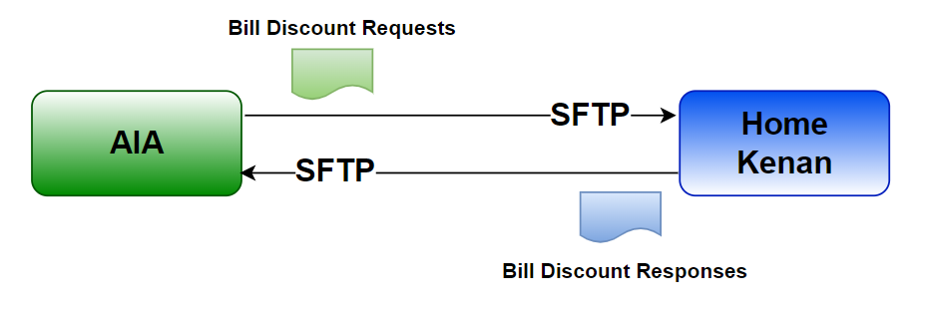

### Flow Description

1. AIA uploads the files to Kenan SFTP remote folder.
2. Home Kenan processes the requests.
3. Home Kenan is responsible for deleting the request files.
4. Home Kenan uploads response files to AIA SFTP remote folder.
5. AIA is responsible for deleting the response files.

For transfer control, a temporary name (*.tmp extension) will be used during the transfer. Upon successful transfer, the file will be renamed to the final name.

### Bill Discount Request

#### General

AIA will be periodically generating bill discount files. One file will be created per campaign.

The files contain bill discount requests created since the generation of the previous files.

| Type | | Description |
| --- | --- | --- |
| **File Format** | Textual, delimited separated values  File encoding: UTF-8 | |
| **File Name Convention** | BILL_DISCOUNT_001_<TIMESTAMP>.txt  <TIMESTAMP> – creation time, format: YYYYMMDDHHMMSS  E.g. BILL_DISCOUNT_001_20220728082906.txt | |
| **File Compression** | None | |
| **Record Format** | Char Encoding: UTF-8  Field delimiter: pipe, “|”. Two consecutive pipes, “||”, denote an empty field value.  New Line Character: EOL (LF)  Header/Trailer record: first row as header  Common Date Time format: YYYYMMDDHH24MMSS  Common Date format: YYYYMMDD | |
| **File Place** | Will be defined during system integration | |
| **Transfer Method** | Using SFTP with private/public keys, password-less | |
| **Number of Files** | 1 file per execution period  If no data is available, a file will not be generated | |

#### Detail Record

| Field No. | Attribute Name | Data Type | Field Description | Sample | Must be populated |
| --- | --- | --- | --- | --- | --- |
|  | Account ID | String | The account external ID | 0123498765 | M |
|  | Campaign Start Date | DateTime | Date of request creation. | 20220728082906 | M |
|  | Campaign End Date | DateTime | End date for the campaign. | 20220801082906 | M |
|  | Discount Amount | Decimal(12,2) | Discount amount.  UOM: Peso | 120 | M |
|  | Payment Required | Decimal(12,2) | Payment amount required.  UOM: Peso | 400.15 | O |
|  | Remarks | String(80) | Free text |  | O |
|  | Transaction ID | String(64) | Unique transaction ID generated by AIA |  | M |

#### Frequency

Every 15 minutes

#### Error/Recovery Handling

AIA responsibility:

If there is an error in the file transfer, the client will retry the operation.

Kenan responsibility:

If there are multiple files in the folder, processing will be done following the files’ timestamp in the file name.

#### Data Security

The transfer protocol is Secured File Transfer Protocol (sFTP) using RSA authentication keys.

### Bill Discount Response

#### General

Home Kenan will be periodically generating bill discount response files. One file will be created in each period.

The file contains bill discount responses created since the generation of the previous file.

| Type | | Description |
| --- | --- | --- |
| **File Format** | Textual, delimited separated values  File encoding: UTF-8 | |
| **File Name Convention** | BILL_DISCOUNT_RESPONSE_<TIMESTAMP>.txt  <TIMESTAMP> – creation time, format: YYYYMMDDHHMMSS  E.g. BILL_DISCOUNT_RESPONSE_20220728082906.txt | |
| **File Compression** | None | |
| **Record Format** | Char Encoding: UTF-8  Field delimiter: pipe, “|”. Two consecutive pipes, “||”, denote an empty field value.  New Line Character: EOL (LF)  Header/Trailer record: first row as header  Common Date Time format: YYYYMMDDHH24MMSS  Common Date format: YYYYMMDD | |
| **File Place** | Will be defined during system integration | |
| **Transfer Method** | Using SFTP with private/public keys, password-less | |
| **Number of Files** | 1 file per execution period  If no data is available, a file will not be generated | |

#### Detail Record

| Field No. | Attribute Name | Data Type | Field Description | Sample | Must be populated |
| --- | --- | --- | --- | --- | --- |
|  | Account ID | String | The account external ID | 0123498765 | M |
|  | Transaction ID | String(64) | The unique transaction ID generated by AIA and populated in the request file. |  | M |
|  | Credit Adjustment Date | DateTime | Date and Time where (last) adjustment was credited. | 20220801082906 | M |

#### Frequency

Every 15 minutes

#### Error/Recovery Handling

Kenan responsibility:

If there is an error in the file transfer, the client will retry the operation.

AIA responsibility:

If there are multiple files in the folder, processing will be done following the files’ timestamp in the file name.

#### Data Security

The transfer protocol is Secured File Transfer Protocol (sFTP) using RSA authentication keys.

# Open Issues

| OI ID# | Description | Status | Actions |
| --- | --- | --- | --- |
| 1. 1 | Decide whether AIA will push the files or Kenan will pull the files from AIA SFTP | Closed | AIA will push the files |